Phase2_Week 1_Day 1

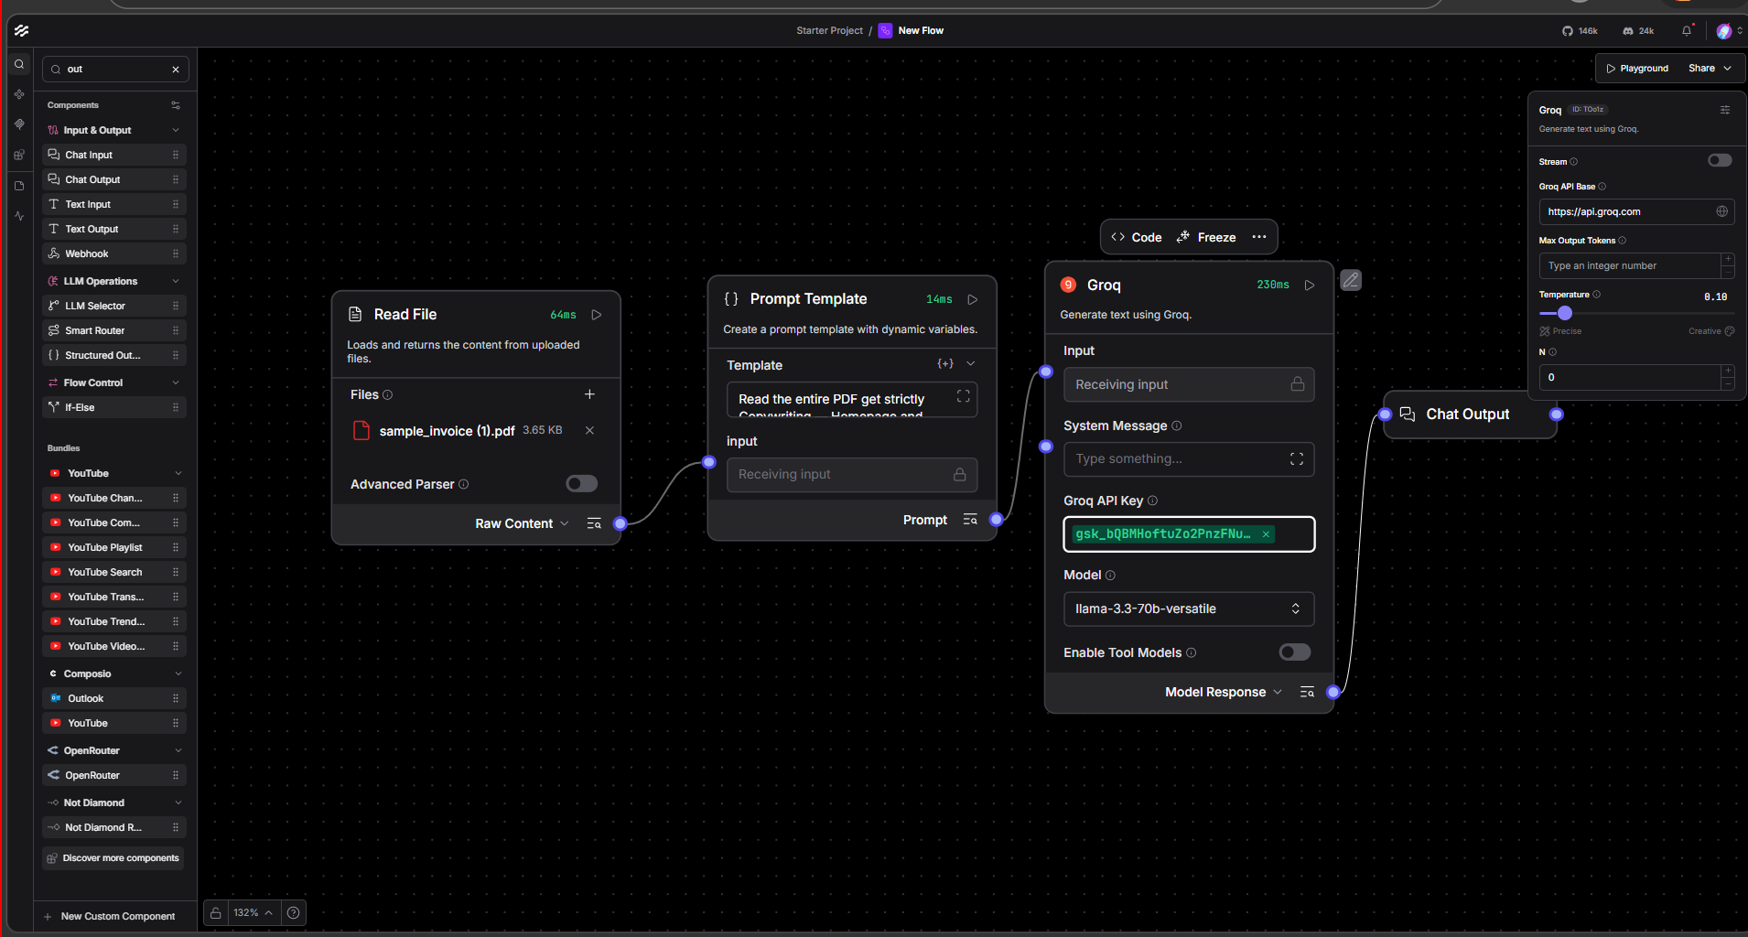

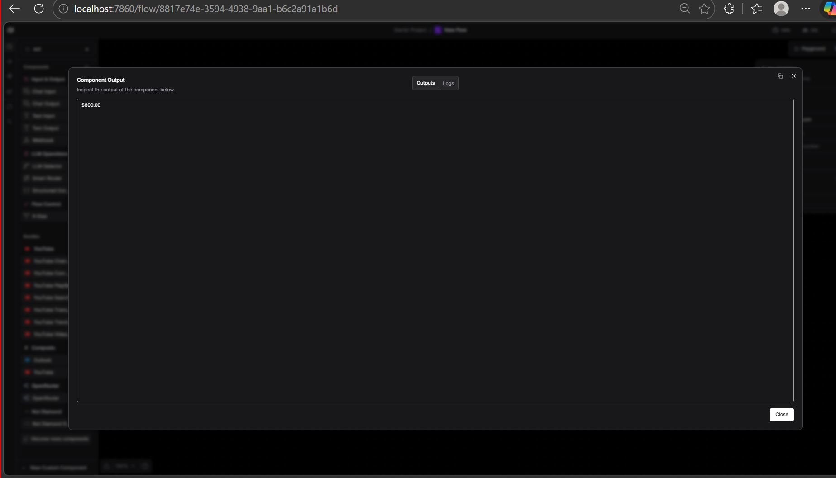

Phase 2 – Week 1, Day 1: Building an AI Flow in Langflow
This assignment demonstrates building a simple AI-powered document processing pipeline using Langflow (a visual, no-code/low-code tool for chaining AI components).

What the Flow Does
The pipeline reads a PDF file, sends its content to an LLM (via Groq), and outputs the result. Here's how each component works:
Image 1 — The Flow Canvas:
The flow has three connected nodes:
- Read File — Loads a PDF (sample_invoice (1).pdf, 3.65 KB) and extracts its raw text content. The "Advanced Parser" option is toggled off, meaning it uses basic text extraction.
- Prompt Template — Takes the raw file content and injects it into a prompt. The visible text suggests a prompt like "Read the entire PDF get strictly Copywriting – Homepage and..." — likely asking the LLM to extract or summarize specific information from the invoice.
- Groq (LLM) — Sends the assembled prompt to the Llama-3.3-70b-versatile model via Groq's API. Key settings visible on the right panel:
  - Temperature: ~0.19 (low = more factual/deterministic output)
  - Groq API Key is connected
  - Output feeds into a Chat Output node
Image 2 — The Result:
After running the flow, the Component Output panel shows the result: $600.00 — meaning the AI successfully read the invoice PDF and extracted the total amount ($600) from it.

